Software Requirements Specification

for

Invertis Grievance Redressal System

Version 1.0 approved

Prepared by Utkarsh Agnihotri, Rohit Kumar

B.Tech.C.S. Sem V, Invertis University

24-Nov-19

# Introduction

## Purpose

The purpose of this project is to build an online Grievance Redressal system for registering all the grievances and complaints that can in turn result in proper authorized functioning of the organization.

## Intended Audience

This project is useful for online Redressal for the grievances of different departments. The main entities that this project is targeted for are students, faculty, workers and authorities which have the role to lodge a query and respectively department by department work upon the solution of a Redressal.

## Project Scope

The scope of this project is limited to the UGC guidelines, can be accessed over a wide range of devices or frameworks. For the prototype we’d use a local server which could later be moved onto AWS or Azure.

# Overall Description

## Product Perspective

The Online Grievance Redressal system can handle a wide variety of information under the given query, it traverses through all the important entities to complete a function or close a Redressal after successful completion and check on both sides of the authority and redresser.

## Product Functions

The major functions of the IGRS are mentioned briefly in the following Entity-Relationship Diagram

## User Classes and Characteristics

Users of the system should be able to lodge a complaint or query or in simple words, raise a query regarding the redress subject, be it electricity, hostel related, mess related etc. then a query no. is given to the Redressal which needs to be solved by the respective departments under the authority, the circulation of the query depends on the magnitude of the query created, the admin has the right to formulate and rate the query as to which department should look into it.

## Operating Environment

The operating environment for the Grievance Redressal System is listed below:

Client/Server System

Operating System-varies by device

Database-SQL

Platform-Visual Studio C#, Java, PHP

Web Platform-HTML5, CSS3, JavaScript, PHP

# External Interface Requirements

## User Interfaces

Front End Software: Visual Studio C#

Back End Framework: Java, PHP

## Hardware Interfaces

Devices connected to the internet

A browser which supports HTML, JavaScript

## Software Interfaces

Following are the software used for the integration of Invertis Grievance Redressal System

|  |  |
| --- | --- |
| **Software Used** | **Description** |
| Operating System | Depends on the device accessing the internet, all internet connecting OS are supported |
| Database | To save the files and other relevant information |
| Visual Studio | The prototype of the project is based on Java and PHP and uses Visual studio for Visual Integration |

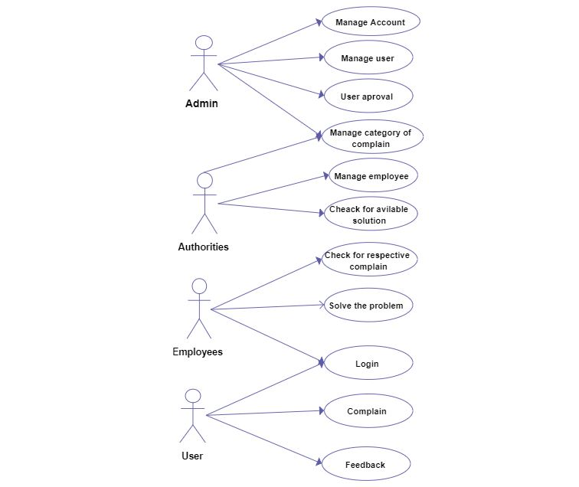

**E.R Diagram**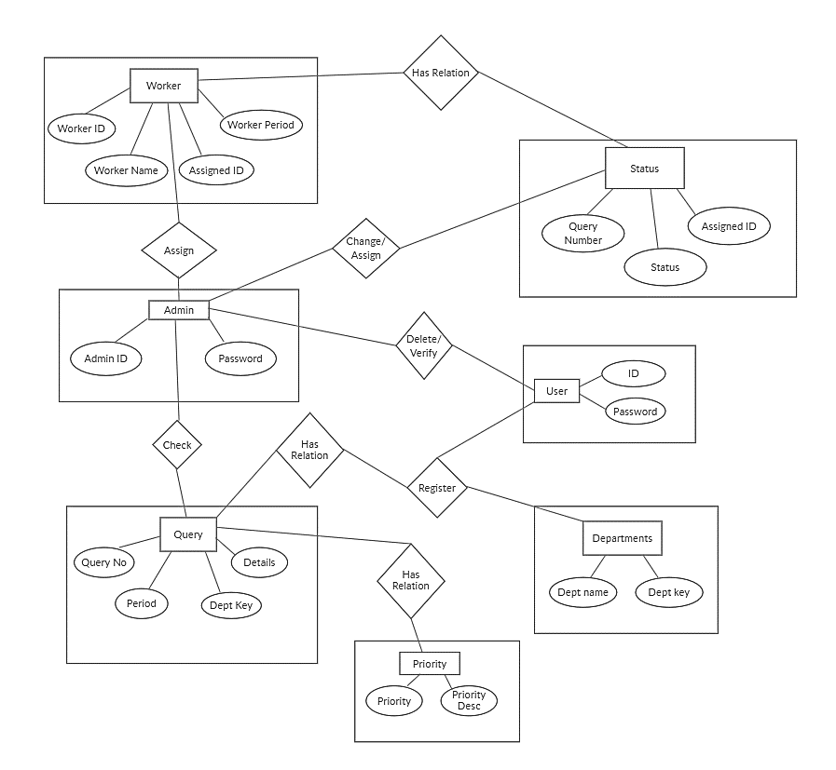

**DFD Level 0**

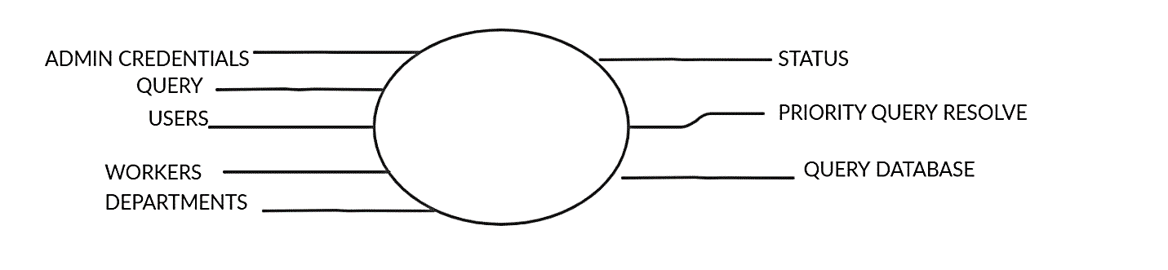

**DFD Level 1**